* INTRODUCTION

The world’s population is more than three times larger than it was in the mid-twentieth century. The global human population reached 8.0 billion in mid-November 2022 from an estimated 2.5 billion people in 1950, adding 1 billion people since 2010 and 2 billion since 1998. The world’s population is expected to increase by nearly 2 billion persons in the next 30 years, from the current 8 billion to 9.7 billion in 2050 and could peak at nearly 10.4 billion in the mid-2080s.

This dramatic growth has been driven largely by increasing numbers of people surviving to reproductive age, the gradual increase in human lifespan, increasing urbanization, and accelerating migration. Major changes in fertility rate have accompanied this growth. These trends will have far-reaching implications for generations to come

* PROBLEM DEFINITION & DESIGN THINKING

2.1 EMPATHY MAP

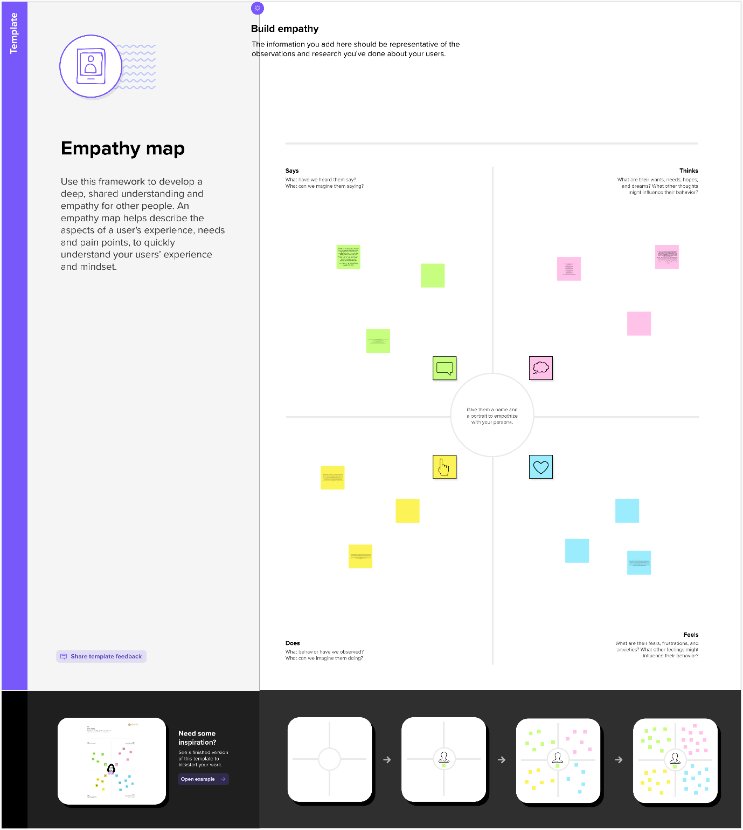

2.2 IDEATION &BRAINSTORMING MAP

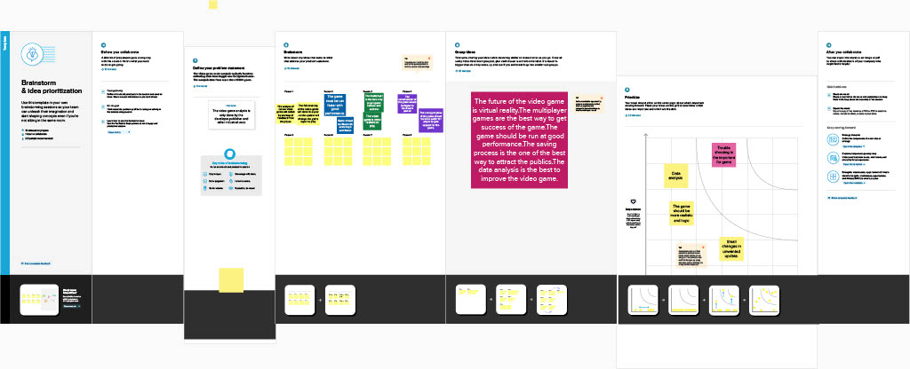

* RESULT

Data collection is the process of gathering and measuring information on variables of interest, in an established systematic fashion that enables one to answer stated research questions, test hypotheses, and evaluate outcomes and generate insights from the data.

* ADVANTAGES

1. Increased human capital
2. More scope for innovation, invention and creative genius
3. Economies of scale from higher population.
4. Enables specialisation
5. Higher population densities more efficient

* DISADVANTAGES

1. Increased pressures on natural environment
2. Water shortages
3. Increases pollution
4. Exacerbates global warming
5. More waste creation

* APPLICATIONS
* The UN projects that the global population will increase from a population of around 8 billion in 2022 to 10.4 billion by the end of the century. By that time, the UN projects, fast global population growth will come to an end. jump to section
* Beneath the global level, there are of course big differences between different world regions and countries. While in some regions the world population will likely grow rapidly for the coming decades, other regions will continue to see declining population numbers. jump to section
* Global population growth is determined by the number of births and deaths. Improving health is increasing the size of the population as it is decreasing mortality.
* CONCLUSION

In 2011, the global population reached the 7 billion mark, it stands at almost 7.9 billion in 2021, and it's expected to grow to around 8.5 billion in 2030, 9.7 billion in 2050, and 10.9 billion in 2100.

* FUTURE SCOPE

The world's population is expected to increase by nearly 2 billion persons in the next 30

years, from the current 8 billion to 9.7 billion in 2050 and could peak at nearly 10.4 billion in

the mid-2080s

* APPENDIX

1. SOURCE CODE

* DASHBOARD: <https://public.tableau.com/shared/6WYQH786K?:display_count=n&:origin=viz_share_link>
* STORY :

https://public.tableau.com/views/Book1_16813639338920/Story1?:language=en-GB&:display_count=n&:origin=viz_share_link

* STORY

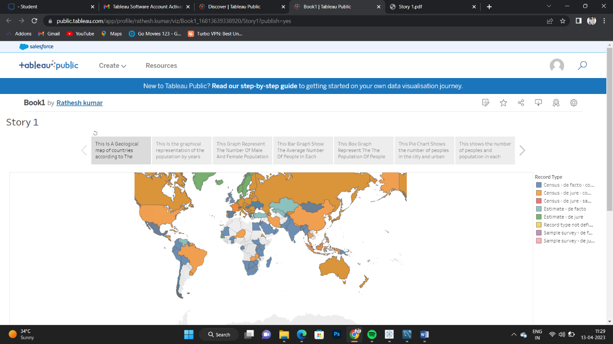

* DASHBOARD

